**Hematopoietic stem cell transplantation in thalassemia: a systematic review of literature and meta analysis of prospective controlled trials**

**ABSTRACT:**

**BACKGROUND:** Stem cell transplant is a potential curative treatment of thalassemia. Since the first stem cell transplant in 1980’s, done for thalassemia , there have been numerous studies involving the use of stem cell transplantation for myeloablative and non myeloablative conditioning regimens. The sources of stem cells in these studies have varied from related or unrelated matched donor bone marrow transplant, peripheral blood stem cell transplant, umbilical cord blood transplantation to the recent intrauterine bone marrow transplant, still in its nascent stages. Thus we sought to perform a meta analysis incorporating all available prospective controlled trials to evaluate the overall survival, disease free survival and transplant related morbidity and mortality in thalassemia patients receiving different sources of stem cells for their transplantation..

**METHODS:** The authors conducted a systematic review and meta-analysis of prospective controlled trials including patients with Pesaro Risk Class 1,2,3 who received Stem cell transplant from Allogeneic Matched Related Bone Marrow Hematopoietic Stem Cells (MRD-BM), Allogeneic Matched Unrelated Bone Marrow Hematopoietic Stem Cells (MUD-BM), Allogeneic Matched Sibling Bone Marrow Hematopoietic Stem Cells (MSD-BMT), Peripheral Blood Hematopoietic Stem Cells (PBHSC), Umbilical Cord Blood Hematopoietic Stem Cells (UCBHSC) with each other using a conditioning regimen which can be either myeloablative or non-myeloablative or both. Relative risks (RRs) with 95% confidence intervals (CIs) were estimated and pooled.

**RESULTS:** Overall, there was no increase in overall survival of patients in BMT to PBHSCT (RR, 0.94; 95% CI, 0.88-1.02, 4 trials, 602

patients ) patients, no significant increase in DFS in patients of BMT compared to PBHSCT (RR, 1.00; 95% CI, 0.89-1.12, 4 trials, 602 patients ) and no decrease in Engraftment in patients of BMT compared to PBHSCT (RR, 1.02; 95% CI, 0.94-1.10, 4trials, 602 patients ). Umbilical Cord Blood Hematopoietic Stem Cells (UCBHSC) cannot be compared to either of these two due to insufficient data. On further analysis of BMT through network meta analysis, no decrease in overall survival of patients can be seen in patients undergoing MUD-BMT (RR, 0.87; 95% CI, 0.79-1.29, 2 trials 131 patients) or any increase in overall survival in MSD-BMT RR, 0.87; 95% CI, 0.74-1.03, 2 trials 131 patients) compared to MRD-BMT. Similarly, no increase in DFS in patients of MSD-BMT (RR, 0.99; 95% CI, 0.85-1.14, 2 trials 131 patients) or decrease in MUD-BMT (RR, 0.87; 95% CI, 0.69-1.10, 2 trials 131 patients) when compared to MRD-BMT Engraftment in patients of MUD-BMT showed no decrease (RR, 1.00; 95% CI, 0.79-1.26, 2 trials 131 patients ) or MSD-BMT showed no increase (RR, 0.88; 95% CI, 0.80-0.96, 2 trials 131 patients ) when compared to MRD-BMT.

**CONCLUSIONS:** Overall,peripheral hematopoietic stem cells should be preferred over BMT owing to its lower post transplant side effect profile. . Matched related donor BMT has no survival advantage or disadvantage over matched unrelated donor BMT and matched sibling donor BMT.

**BACKGROUND:**

The term Thalassemia is derived from the Greek word ‘’Thalassa”(Sea) and ‘’Haema’’(Blood) and represent the world’s most common monogenic disease [1]. Thalassemia refers to disorders associated with defective synthesis of α or β globin subunits of hemoglobin (Hb) A (α2; β2) inherited as pathological alleles of one or more of the globin genes located on Chromosome 11(β) and 16(α). The thalassemia syndrome is classified according to which globin chains, α or β, is affected. The two major groups, α and β thalassemia are classified according to absent(α0β0) or reduced(α+β+) globin chain synthesis. Thalassemia is characterized by ineffective erythropoiesis with aggressive extension of the rapidly proliferating erythrocytes into intra- and extra-medullary areas, not usually occupied by marrow. This results in major bone remodeling together with marked hepatomegaly and splenomegaly. Thalassemia has a very wide clinical range of severity. The degree of imbalance in the ratio of β-globin chain to α-globin chain in red blood cells (RBCs) appears to be directly linked to the severity of β-thalassemia. Thalassemia major (TM) is the severe form of the disease, presenting with transfusion-dependent anemia, generally in the first year of life. Due to migration, thalassemia is no longer confined to the tropical areas of its origin ; rather, it has become an important part of clinical practice in Europe, United States (US) and Australasia. In the US there aremore than 1000 patients with diagnosis of Thalassemia major. Concurrently, there have been significant improvements in supportive care available for TM, thus extending the lifespan of affected patients and altering the age distribution of this patient population [3]. Patients typicallydie from complications of iron overload if iron chelation is not provided [4]. Iron chelation therapy is expensive and some patients may not be compliant. At present, hematopoietic stem cell transplantation (HSCT) is the only curative treatment for TM by correcting the genetic defect and has been reported by various centers [5-7]. The first two transplant procedures for the treatment of thalassemia with marrow from matched related donors were performed in December 1981, in Seattle, WA, and in Pesaro, Italy. The Seattle approach was based on the assumption that the risks associated with BMT would be increased by the iron overload. Therefore, the Seattle group attempted to reduce this of sensitization to human leukocyte antigens (HLAs) induced by hypertransfusionby usinga cohort of young the patients who have not previously been transfused. The Pesaro approach was based on an assessment that restricting transplants to untransfused patients was impracticable and so the cohort of patients consisted of mainly adults and had received several transfusion in the past. The Pesaro approach seems more clinically relevant,as the patients, in most similar instances, have received many transfusion by the time they are being treated by stem cell transplant. Certainly the freedom from transfusion and its related infectious complications is a distinct advantage of hematopoietic stem cell transplantation and in many cases, results in significant improvement of the quality of life.

**OBJECTIVES:**

To evaluate the effectiveness and safety of different types of hematopoietic stem cell transplantation, in people with severe transfusion-dependant thalassaemiaor thalassaemia variants requiring chronic blood transfusion.

**MATERIALS AND METHODS:**

**Data source**

We conducted a comprehensive search strategy with no restriction on language or study years to identify published clinical trials. Relevant trials were identified by searching the Cochrane Library, MEDLINE,EMBASE and GOVERNMENT CLINICAL TRIAL REGISTRY till July 2015 using the search words ‘HEMATOPOIETIC STEM CELL TRANSPLANTATION IN THALASSEMIA’, ‘BONE MARROW STEM CELL IN THALASSEMIA’, ‘PERIPHERAL BLOOD STEM CELL TRANSPLANTATION IN THALASSEMIA’, ‘UMBILICAL CORD BLOOD TRANSPLANTATION IN THALASSEMIA’, INTRAUTERINE BONE MARROW TRANSPLANTATION IN THALASSEMIA’, ‘TREATMENT IN THALASSEMIA’.

**Selection criteria**

Prospective controlled trials comparing allogeneic hematopoietic stem cell transplantation from Allogeneic Matched Related Bone Marrow Hematopoietic Stem Cells (MRD-BM), Allogeneic Matched Unrelated Bone Marrow Hematopoietic Stem Cells (MUD-BM), Allogeneic Matched Sibling Bone Marrow Hematopoietic Stem Cells (MSD-BMT), Peripheral Blood Hematopoietic Stem Cells (PBHSC), Umbilical Cord Blood Hematopoietic Stem Cells (UCBHSC) with each other using A conditioning regimen which can be either myeloablative or non-myeloablative or both.

**Data collection and analysis**

Two review authors independently screened studies and had planned to extract data and assess risk of bias using standard Cochrane Collaboration methodologies. We included trials that included patients from Pesaro Risk Classification 1, 2 and 3 because most of the patients in the trials were classified according to Pesaro Risk Classification, irrespective of the comorbidities that the patients were having at the time of intervention. Trials were included only once in the analysis using the most updated data. Interventions that were assessed include BMT(MRD-BM and MUD-BM and MSD-BMT grouped together as OTHER BMT), PBHSCT and UCBHSCT.

**Data Extraction**

Two reviewers independently extracted data from included trials (A.D and A.N). In case of any disagreement between the 2 reviewers, a third reviewer extracted the data (S.A). The statistical software and data outcome was operated by a statistician (K.K.D).

**Risk of Bias Assessment**

Because the different trial arms were not randomized and prospectively controlled, various characteristics may not be well balanced and may carry a potential for bias. Thus, trialsthat fulfilled the review inclusion criteria were assessed for methodological quality by 2 reviewers (A.F, A.N and A.D). Not reporting of any of the items was considered ashigh risk for bias. Since our study included prospective controlled trials, we did not asses the methods used for sequence generation, allocationsequence concealment, blinding, and exclusions fromanalysis by using standard methods as recommended in the Cochrane Handbook [8,9].We did not consider any violation of ITT as an important risk of bias domain for prospective controlled trials .

The second step was to assess the following domains:

1. Method of tissue typing: Because genetic randomization depends on the assessment of sibling matching, adequate human leukocyte antigen

(HLA) typing and reporting must be ensured.

2. Comparability of potential confounders: The comparability of the study groups was assessed basedon the following confounders: age, patient’s risk

group (Pessaro Risk Class 1, 2 and 3), pre-conditioning and conditioning myeloablative and non-myeloablative regimen , level of mixed chimerism development and post transplant graft versus host prophylaxis.

**Primary outcomes**

1.Overall survival (OS) of the transplanted patients irrespective of the complications of transplantation (either thalassaemia manifestations and transfusion dependantor adverse effects of the transplant procedure like graft failure, grade III/IV acute GVHD, or both) and the quality of life after transplantation. Time period to be reported after at least 1 year of follow-up.

2.Disease-free survival (DFS) (event is defined as either thalassaemiamanifestations or adverse effects of the transplant procedure like graft failure, grade III/IV acute GVHD, or both) the interval from time of randomization or study entry to the first recurrence of event or to death of any cause. Time period to be reported after at least 1 year of follow-up.

3.Engraftment (described as the successful implantation of graft and transfusion independent survival) rounds up another important aspect of the outcome.

**Secondary Outcomes**

1.Acute GVHD (aGVHD) (Grade 1-Grade 4) which determines the immediate success of the transplantation and implies the need for second transplantation and is significant controller of the mortality in transplanted patients.

2.Chronic GVHD (cGVHD) (Limited and extensive) which determines the morbidity of the transplanted patients and governs the quality of life post transplant.

3.Transplant Related Mortality(TRM) (Includes both Rejection and non-Rejection mortality) which indicates the efficacy of the transplantation and also indicates at the mortality due to pre-existing comorbidities, conditioning regimen toxicity andtransplantation process.

**Data Synthesis and Analysis**

Dichotomous data (Occurrence / Non-occurrence) were analyzed for each effect - Primary (Overall Survival, Disease Free Survival and Engraftment) and Secondary (acute GVHD, chronic GVHD and Transplant Related Mortality), by calculating the relative risk (RR) for the effect corresponding to each individual trial along with the 95% confidence interval(CI). The main focus of our analysis was twofold

* To compare between BMT and the PBHSCT procedures in terms of the primary and the secondary effects.
* To compare among the different sub-types of BMT, namely MRD-BMT, MUD-BMT and MSD-BMT. We are mainly interested in figuring out if MRD-BMT or MSD-BMT (where the donor stem cells come from related individuals or siblings) are found to be better than MUD-BMT (where the donor stem cells come from unrelated individuals who pass the HLA matching test).

For the first comparison, we concentrated on trials with dichotomous data on the various effects for both BMT and PBHSCT. We fitted the Mantel-Haenszel random-effects model to the RR values across trials in order to account for the expected heterogeneity between studies related to different distribution of disease risk characteristics. Figures 1 and 2 present the meta analysis of the relative risk (RR) across the different trials for the primary effects and the secondary effects respectively. Negative estimates of RR would mean that the probability of occurrence of the corresponding primary or secondary effect in BMT is less compared to that is PBHSCT. In Figure 3, we tested for the publication bias for each trial for a given effect. None of the trials showed publication bias, as is evident from the funnel plot as well as the Begg and Egger tests. The entire analysis and the plots were implemented using the packages **metaphor** and **rmeta**  in R 3.2.0 [39, 40, 41].

For the threefold comparison among MRD-BMT, MUD-BMT and MSD-BMT, we did a network based meta analysis using the package **netmeta** in R 3.2.0 [39,42]. We had one trial due to Gaziev 2013 that compared the MRD-BMT against MSD-BMT and one trial due to Hongeng 2006 that compared MRD-BMT against MUD-BMT []. We set MRD-BMT as the reference frame and calculated the RR of the other two BMT mechanisms against this reference. We wanted to see how different MSD-BMT and MUD-BMT are relative to MRD-BMT in terms of the different primary and secondary effects. Figure 4 presents the comparative meta analysis of the three BMT mechanisms through forest plots for each effect.

**RESULTS:**

The search yielded 104 associated results, and 60 potentially important results,31 relevant clinical trials which were considered for further investigation; however, 22 of the 29 studies were excluded.7 clinical trials that comprised 958 patients fulfilled inclusion criteria [24, 27-28, 30, 34-35, 38].One trial [34] did not report on OS, DFS and Engraftment and cannot be included except in the secondary outcome analysis. Five trials compared PBHSCT to BMT[27, 28, 30, 34, 35], one trial compared MRD-BMT to MUD-BMT[24], one trial compared MRD-BMT to MSD-BMT[38].The definition of Pesaro Risk Classification patients was consistent between trials except in one trial [35].The mean duration of follow-up among all studies was 33 months (range, 24-72 months).All trials used myeloablative or non-myeloablative conditioning regimen as summarized in Table 1. Data regarding demographics and Pesaro Risk Classes are summarized in Table 2. for various

reasons (Fig. 1). Seven trials (3 comparisons) conducted between 2006 and

Comparative Prospective Clinical Trial without Primary Outcome (n=1)34

Non-Comparative Prospective Clinical Trials not compatible with inclusion criteria (n=24)10-23,26,29,31-33,36-37

Case Reports, Letter to the Editor, Review and Duplication (n=29)

Results not associated with HSCT in Thalassemia alone (n=44)

Relevant Electronic search results (n=104)

Relevant associated Clinical Manuscripts (n=60)

Potential relevant Clinical trials identified and retrieved (n=31)

Prospective comparative Clinical Trials retrieved for further evaluation (n=7)

Randomised Prospective Comparative Clinical Trials included in the Meta-analysis (n=6)

Fig1. Trial flow according to quality of reporting Meta-analysis (QUOROM) is shown.Superscript indicate the Clinical Trials.

**Assessment of Risk of Bias**

Seven trials that compared MUD-BMT, MSD-BMT, MRD-BMT, PBHSCT, UCBHSCT were prospective controlled. Most of the studies reported data on potential confounders (Table 2).None of the trials were blinded.

**BMT *Versus* PBHSCT:**

**Primary Outcomes**

**Overall Survival (OS):**

There was a significant increase in OS in patients undergoing BMT compared to PBHSCT (RR, 0.94; 95% CI, 0.88-1.02, 4 trials, 602

patients) .We considered each of the trials individually . All trials showed the increase in OS with BMT compared to PBHSCT except in IB Resnick 2007 and Chunfu Li 2012 where OS was higher in PBHSCT compared to BMT. On network analysis No significant decrease in OS can be perceived in MUD-BMT (RR, 0.87; 95% CI, 0.79-1.29, 2 trials 131 patients) nor any increase in overall survival in MSD-BMT RR, 0.87; 95% CI, 0.74-1.03, 2 trials 131 patients) compared to MRD-BMT.

**Disease Free Survival (DFS):**

Similar outcome was reflected in DFS where there was a significant increase in DFS in patients undergoing BMT compared to PBHSCT(RR, 1.00; 95% CI, 0.89-1.12, 4 trials, 602 patients) except in one trial where DFS for BM was low compared to PBHSCT (RR, 0.92; 95% CI, 0.77-1.11, 1 trial, 82 patients).On network analysis taking MRD-BMt as the standard, no increase in DFS in patients of MSD-BMT (RR, 0.99; 95% CI, 0.85-1.14, 2 trials 131 patients) or decrease in MUD-BMT (RR, 0.87; 95% CI, 0.69-1.10, 2 trials 131 patients) when compared to MRD-BMT .

**Engraftment:**

Engraftment, which was the third important factor in primary outcome showed patients undergoing BM had significantly decreased. Engraftment than PBHSCT (RR, 1.02; 95% CI, 0.94-1.10, 4trials, 602 patients). But two trials Chunfu Li 2012 and A. Ghavamzadeh 2008 showed contrary results. Similarly, Engraftment in patients of MUD-BMT showed no decrease (RR, 1.00; 95% CI, 0.79-1.26, 2 trials 131 patients ) or MSD-BMT showed no increase (RR, 0.88; 95% CI, 0.80-0.96, 2 trials 131 patients ) when compared to MRD-BMT.

**Secondary Outcome:**

**Acute GVHD :**

There was a significant decrease in aGVHD in patients undergoing BMT compared to PBHSCT (RR,0.75; 95% CI, 0.61-.0.92, 5 trials, 827 patients).On network analysis keeping MRD-BMT as the standard, no increase in aGVHD in MUD-BMT (RR, 1.33; 95% CI, 0.76-2.35, 2 trials 131 patients) or any decrease in aGVHD in MSD-BMT (RR, 1.94; 95% CI, 0.67-5.65, 2 trials 131 patients) can be observed with respect to MRD-BMT.

**Chronic GVHD:**

Similar outcome was shown in cGVHD with patients undergoing BMT having a significant decrease in cGVHD than patients undergoing PBHSCT (RR, 0.37; 95% CI, 0.24-0.54, 5 trials, 827 patients). cGVHD in patients undergoing MUD-BMT showed no significant difference (RR, 0.89; 95% CI, 0.29-2.76, 2 trials 131 patients ) or MSD-BMT showed no decrease (RR, 0.85; 95% CI, 0.19-3.70, 2 trials 131 patients ) when compared to the standard MRD-BMT.

**Transplant Related Mortality (TRM):**

Transplant related mortality was considered a final secondary outcome in these studies. TRM was also decreased in patients undergoing BMT compared to patients undergoing PBHSCT (RR,0.67; 95% CI, 0.34-1.35, 4 trials, 602 patients).Two trials notably IB Resnick 2007 and Chunfu Li 2012 disagreed with the result outcome of TRM Similarly, no difference in TRM in patients of MSD-BMT (RR, 1.21; 95% CI, 0.15-9.67, 2 trials 131 patients) or increase in MUD-BMT (RR, 2.00; 95% CI, 0.37-10.92, 2 trials 131 patients) can be established when compared to MRD-BMT .

**PUBLICATION BIAS:**

The results of the Begg’s and Egger’s tests showed no significant indication of publication bias (Figure 4). Therefore, it is unlikely that publication bias had a major influence on the results of the study.

**DISCUSSION:**

Thalassemia is a very common disease and is regarded as the world’s commonest monogeneic disease. Stem cell transplantation, remains the mainstay of curative treatment in thalassemia. Therefore, patients with thalassemia should receive stem cell transplantation at an early age, rather than depend solely on the conventional therapy of blood transfusion and iron chelation. Overwhelmingly, comprehensive evidence has shown that stem cell transplantation yields better result for the patients in the long run. The choice of stem cell transplant for the physician in thalassemia ranges from BMT, PBHSCT and UCBHSCT. Furthermore, among BMTs there can be MRD-BMTand MUD-BM and MSD-BMT.The current clinical practise mostly relies on MRD-BMT for hematopoietic stem cell transplantation in thalassemia although MSD-BMT may be considered the best mode of donor stem cell but practically always not possible to procure. .The objective of our review is to identify which stem cell transplantation method leads to better post-transplant outcomes. We included 7 randomized control trials that comprised of 958 patients and compared MRD-BMT with MUD-BMT and MSD-BMT and PBHSCT.

We observed no increase in OS of patients in BMT to PBHSCT (RR, 0.94; 95% CI, 0.88-1.02, 4 trials, 602

patients )or no statistically significant increase in DFS in patients of BMT compared to PBHSCT (RR, 1.00; 95% CI, 0.89-1.12, 4 trials, 602 patients ).Similarly no decrease in Engraftment in patients of BMT compared to PBHSCT (RR, 1.02; 95% CI, 0.94-1.10, 4trials, 602 patients ) can also be appreciated. When considering aGVHD , BMT patients showed a statistically significant decrease in a GVHD compared to PBHSCT (RR,0.75; 95% CI, 0.61-.0.92, 5 trials, 827 patients ). BMT patients also showed a decrease in cGVHD compared to PBHSCT patients (RR, 0.37; 95% CI, 0.24-0.54, 5 trials, 827 patients ) though the same cannot be exactly stated regarding TRM where BMT patients showed no decrease in TRM compared to PBHSCT (RR,0.67; 95% CI, 0.34-1.35, 4 trials, 602 patients ).

In another observation, on further analysis of BMT through network meta analysis, no decrease in overall survival of patients can be seen in patients undergoing MUD-BMT (RR, 0.87; 95% CI, 0.79-1.29, 2 trials 131 patients) or any increase in overall survival in MSD-BMT RR, 0.87; 95% CI, 0.74-1.03, 2 trials 131 patients) compared to MRD-BMT. Similarly, no increase in DFS in patients of MSD-BMT (RR, 0.99; 95% CI, 0.85-1.14, 2 trials 131 patients) or decrease in MUD-BMT (RR, 0.87; 95% CI, 0.69-1.10, 2 trials 131 patients) when compared to MRD-BMT Engraftment in patients of MUD-BMT showed no decrease (RR, 1.00; 95% CI, 0.79-1.26, 2 trials 131 patients ) or MSD-BMT showed no increase (RR, 0.88; 95% CI, 0.80-0.96, 2 trials 131 patients ) when compared to MRD-BMT. When considering aGVHD, keeping MRD-BMT as the standard, no increase in aGVHD in MUD-BMT (RR, 1.33; 95% CI, 0.76-2.35, 2 trials 131 patients) or any decrease in aGVHD in MSD-BMT (RR, 1.94; 95% CI, 0.67-5.65, 2 trials 131 patients) can be observed with respect to MRD-BMT.. Contrary to the popular belief and practise, cGVHD in patients undergoing MUD-BMT showed no significant difference (RR, 0.89; 95% CI, 0.29-2.76, 2 trials 131 patients ) or MSD-BMT showed no decrease (RR, 0.85; 95% CI, 0.19-3.70, 2 trials 131 patients ) when compared to the standard MRD-BMT. Similarly, no difference in TRM in patients of MSD-BMT (RR, 1.21; 95% CI, 0.15-9.67, 2 trials 131 patients) or increase in MUD-BMT (RR, 2.00; 95% CI, 0.37-10.92, 2 trials 131 patients) can be established when compared to MRD-BMT .can be seen in TRM where MRD-BMT patients showed no significant decrease in TRM compared to Other BMT (RR, 0.61; 95% CI, 0.16-2.27, 2 trials, 131 patients).

The interpretation of these results is that, overall BMT cannot be touted as far superior to PBHSCT as a mode of stem cell transplantation in thalassemia as it may run the same risk of a higher risk of adverse effects like acute GVHD, chronic GVHD and Transplant Related Mortality which play a significant role in morbidity and mortality of the patients post-transplant and severely impairs the the quality of life in those post transplant patients. Considering that there is no significant advantage of using BMT as donor stem cell compared to PBHSC when we consider the overall survival, Disease free survival or engraftment, the much used and much preferred BMT cannot be stated as the best source of donor stem cell in stem cell transplantation in thalassemia. . Another relevant interpretation is the lack of any significant edge of MRD-BMT compared to all other modes of BMT like MSD-BMT and MUD-BMT. Considering MRD-BMT as the standard , we did not find any significant difference between these three BMT when we compare overall outcome, disease free survival or engraftment. The side effect profile quantified by aGVHd,cGVHd and Transplant related mortality in MRD-BMT, MUD-BMT, MSD-BMT remains statistically insignificant thus making it very difficult recommend and prefer any one over the other. These put to rest the speculation that MRD-BMT is far superior to MUD-BMT or inferior to MSD-BMT in thalassemia. This also makes the automatic choice of MRD-BMT as the choice for stem cell transplantation in thalassemia a dubious one. This is an interesting finding considering the fact that nearly one-third of the patients who suffer from thalassemia can find a matched related donor source for their stem cell transplantation. So the large number of patients who cannot find a suitable matched related donor can still undergo transplantation with matched unrelated donor transplantation without any overall decrease in survival or disease free survival compared to matched related donor source of BMT.

There are a number of limitations to this systemic review. Firstly, most clinical trials done so far on stem cell transplant in thalssemia are non-randomised and are mainly prospective controlled clinical trials or single arm clinical trials. We could not include a single randomized controlled trial for our systematic review. Many studies compared only various Conditioning Regimen leaving aside the topic of stem cell transplantation in thalassemia due to which we could not include them in our systematic review. Also we could not conduct subgroup analyses according to specific Pessaro Risk Classification. Specifically, we could not conduct a subgroup analysis based on the age of

patients because of the sparse data in many of the trials. We could not conduct a subgroup analysis based on the Conditioning Regimen of the patients and therefore Effect Modification can be a problem in our studyFurthermore, there are groups of patients for whom our conclusions may not be applicable. The patients who received UCBHSCT cannot be included in subgroup analysis due to paucity of data. So UCBHSC which is another important source of stem cell transplantation in thalassemia has to be left out of this review and cannot be included in the meta-analysis.

**Implications for Practice and for Research**

Our systematic review indicates no overall survival and disease free survival benefit from BMT as a source of stem cell in stem cell transplantation in thalassemia and envisage the use of PBHSC as a better alternative to BMT as donor stem cell in stem cell transplantation in thalassemia due to its lesser side effect profile which significantly lowers the mortality and morbidity in post transplant patients. The advantage of superior survival and less transplantation related side effects cannot be established in MRD-BMT compared to MUD-BMT and the much sought after and gold standard, MSD-BMT thus limiting their automatic choice as a reliable source of stem cell transplant in thalassemia.. The role of UCBHSCT should be assessed in future trials. Future trials should try to use uniform Conditioning Regimen when reporting the outcomes of the different subgroups. Attempts to minimize bias in these trials are crucial. Randomized Controlled Clinical trials are required to answer the question of the best source of donor stem cells in stem cell transplantation in thalassemia.

**CONFLICT OF INTEREST DISCLOSURES:**

The authors made no disclosures.

**REFERENCES:**

1. Weatherall DJ, Clegg JB. Thalassemia-α global public health problem*.Nature Med* 1996; 2: 847–9.

2. Olivieri NF, Brittenham GM*.* Iron chelating therapy and thetreatment of thalassemia*. Blood* 1997; 89: 739–761.

3. Borgna-Pignatti C, Rugolotto S, De Stefano P, et al. Survival and disease complications in thalassemia major*.Ann NY AcadSci* 1998; 850: 227–31.

4. Modell B, Khan M, Darlison M. Survival in β-thalassaemia major in the UK: data from the UK Thalassaemia Register. *Lancet* 2000; 355: 2051–2052.

5. Lucarelli G, Galimberti M, Giardini C et al. Bone marrow transplantation in thalassemia. The experience of Pesaro.*AnnNYAcad Sci*1998; 850: 270–275.

6. Walters MC, Sullivan KM, O’Reilly RJ et al. Bone marrow transplantation for thalassemia. the USA experience. *Am J PediatrHematol Oncol*1994;16: 11–17.

7. Roberts IAG, Darbyshire PJ, Will AM. BMT for children with β-thalassemia major in the UK.*Bone Marrow Transplant* 1997; 19 (Suppl. 2): 60–61.

8. Wheatley K, Gray R. Commentary: Mendelian randomization—an update on its use to evaluate allogeneic stem celltransplantation in leukaemia. Int J Epidemiol. 2004;33:15-17.

9. Higgins JPT, Green S, eds. Cochrane Handbook for SystematicReviews of Interventions 4.2.6 [updated September 2006]. Available at:http://www.cochrane.org/resources/hbook.htm Accessed March 1, 2009

10.G.Lucarelli, M.Galimberti, C.Delfini, et al. Marrow transplant for thalassemia following busulfan and cyclophosphamide. *The Lancet*. 1985.

11.Guido Lucarelli, Maria Galimberti, Paola Polchi, et al. Bone marrow transplantation in patients with thalassemia. *NEJM*.1990; 322(7): 2082-2088

12.Guido Lucarelli, Reginald A. Clift, MariaGalimberti, et al. Marrow transplantation for patients with thalassemia: results in class 3 patients. *Blood.* 1996; 87(5): 2082-2088

13.M Andreani, S Nesci, G Lucarelli, et al. Long-term survival of ex-thalassemic patients with persistent mixed chimerism after bone marrow transplantation. *Bone Marrow Transplantation*. 2000; 25: 401–404

14. D Gaziev, M Galimberti, G Lucarelli, et al. Bone marrow transplantation from alternative donors for thalassemia: HLA-phenotypically identical relative and HLA-nonidentical sibling or parent transplants. *Bone Marrow Transplantation*. 2000; 25: 815–821

15.M Chandy, A Srivastava, D Dennison, et al. Allograftingallogeneic bone marrow transplantation in the developing world: experience from a center in India. *Bone Marrow Transplantation.* 2001; 27:785–790

16.MA Yesilipek, V Hazar, A Ku¨pesiz, et al.Peripheral blood stem cell transplantation in children with beta-thalassemia.*Bone Marrow Transplantation.* 2001; 28: 1037–1040.

17. CK Li1, MMK Shing1, KW Chik1, et al.Haematopoietic stem cell transplantation for thalassaemia major inHong Kong: prognostic factors and outcome. *Bone Marrow Transplantation.*2002; 29: 101–105.

18. LM Ball1, AC Lankester1, PC Giordano2, et al. Paediatric allogeneic bone marrow transplantation for homozygous b-thalassaemia, the Dutch experience.*Bone Marrow Transplantation.*2003; 31: 1081–1087.

19.Franco Locatelli, Vanderson Rocha, William Reed, et al. Related umbilical cord blood transplantation in patients with thalassemia and sickle cell disease.*Blood.* 2003; 101: 2137-2143

20.Pietro Sodani, David Gaziev, Paola Polchi, et al. New approach for bone marrow transplantation in patients with class 3thalassemia aged younger than 17 years. *Blood.* 2004;104:1201-1203.

21.M Iravani, A Mousavi, S Gholibeikian, et al. Cyclosporin A and mini short-term methotrexate vscyclosporinAasgraft-versus-host disease prophylaxis in patients with beta thalassemiamajor undergoing allogeneic blood and marrow transplantation. *Bone Marrow Transplantation*.2005; 35: 1095–1099.

22.G La Nasa1, G Caocci1, F Argiolu, et al. Unrelated donor stem cell transplantation in adult patients with thalassemia. *Bone Marrow Transplantation.*2005; 36: 971–975.

23. M Sauer, C Bettoni, M Lauten, et al. Complete substitution of cyclophosphamide by fludarabine and ATGin a busulfan-based preparative regimen for children and adolescentswithβ-thalassemia.*Bone Marrow Transplantation.*2005; 36: 383–387.

24.Z Feng1, E Sun2, H Lan1, et al. Unrelated donor bone marrow transplantation for β-thalassemia major:an experience from China.*Bone Marrow Transplantation.*2006; 37: 171–174.

25.Suradej Hongeng, SamartPakakasama, AmpaiwanChuansumrit, et al.Outcomes of transplantation with related- and unrelated-donor stem cells in children with severe thalassemia. *ASBMT*. 2006; 12: 683-687.

26.T-H Jaing1, C-P Yang1, I-J Hung, et al. Transplantation of unrelated donor umbilical cord blood utilizingdouble-unit grafts for five teenagers with transfusion-dependentthalassemia.*Bone Marrow Transplantation.*2007; 40: 307–311.

27.IB Resnick, M Aker, P Tsirigotis, MY Shapira, et al. Allogeneic stem cell transplantation from matched related and unrelateddonors in thalassemia major patients using a reduced toxicityfludarabine-based regimen. *Bone Marrow Transplantation.*2007; 40: 957–964.

28. D Dennison, S Al Kindi, A Pathare, et al. Hematopoietic stem cell transplantation in Oman.*Bone Marrow Transplantation.*2008; 42: 109–113

29.Ardeshir Ghavamzadeh,MasoodIravani,AseaehAshouri, et al. Peripheral Blood versus bone marrow as a Source of hematopoietic stem cells for allogeneic transplantation in Children With Class I and II Beta thalassemia major. *ASBMT. 2008;* 14: 301-308.

30. J Gaziev1, P Sodani1, G Lucarelli1, P Polchi, et al. Second hematopoietic SCT in patients with thalassemia recurrencefollowing rejection of the first graft. *Bone Marrow Transplantation.*2008; 42: 397–404

31.Pietro Sodani, AntonellaIsgrò, JavidGaziev, et al. Purified T-depleted, CD34_ peripheral blood and bone marrow celltransplantation from haploidentical mother to child with thalassemia. *Blood.* 2010; 115: 1296-1302*.*

32. I Frugnoli, B Cappelli, R Chiesal, et al. Escalating doses of donor lymphocytes for incipient graft rejectionfollowing SCT for thalassemia. *Bone Marrow Transplantation.*2010; 45: 1047–1051.

33.Mitchell Sabloff, MammenChandy, Zhiwei Wang, et al. HLA-matched sibling bone marrow transplantation for β-thalassemia major. *Blood.* 2011;117: 1745-1750.

34.Yesilipek MA, Ertem M, Cetin M, et al. HLA-matched family hematopoetic stem celltransplantation in children with betathalassemia major: The experience of theTurkish Pediatric Bone MarrowTransplantation Group. *Pediatr Transplantation*. 2012; 16: 846–851.

35. Chunfu Li, Xuedong Wu, XiaoqingFeng, et al.Anovel conditioning regimen improves outcomes in β-thalassemia major patientsusing unrelated donor peripheral blood stem cell transplantation. *Blood.* 2012; 120: 3875-3881.

36. T-H Jaing, I-J Hung, C-P Yang, et al. Unrelated cord blood transplantation for thalassaemia: a single-institutionexperience of 35 patients. *Bone Marrow Transplantation.*2012; 47: 33–39.

37. E Goussetis, I Peristeri, V Kitra, et al. HLA-matched sibling stem cell transplantation in childrenwithβ-thalassemia with anti-thymocyte globulin as partof the preparative regimen: the Greek experience. *Bone Marrow Transplantation.*2012; 47: 1061 – 1066.

38. JavidGaziev, Marco Marziali, AntonellaIsgrò, et al. Bone marrow transplantation for thalassemia from alternative relateddonors: improved outcomes with a new approach. *Blood.*2013; 122: 2751-2756.

39. R Core Team (2012). R: A language and environment for statistical computing. R Foundation for Statistical Computing, Vienna, Austria. ISBN 3-900051-07-0, URL <http://www.R-project.org/>

40. Wolfgang Viechtbauer (2010). Conducting meta-analyses in R with the metafor package. Journal of Statistical Software, 36(3), 1-48. URL <http://www.jstatsoft.org/v36/i03/>.

41. Lumley T (2003). Rmeta version 2.10. R package. <http://cran.r-project.org/web/packages/rmeta/rmeta.pdf>

42. Rucker, G. and Schwarzer, G. (2013b). ¨ netmeta: An R package for network meta-analysis. http://www.r-project.org/. R package

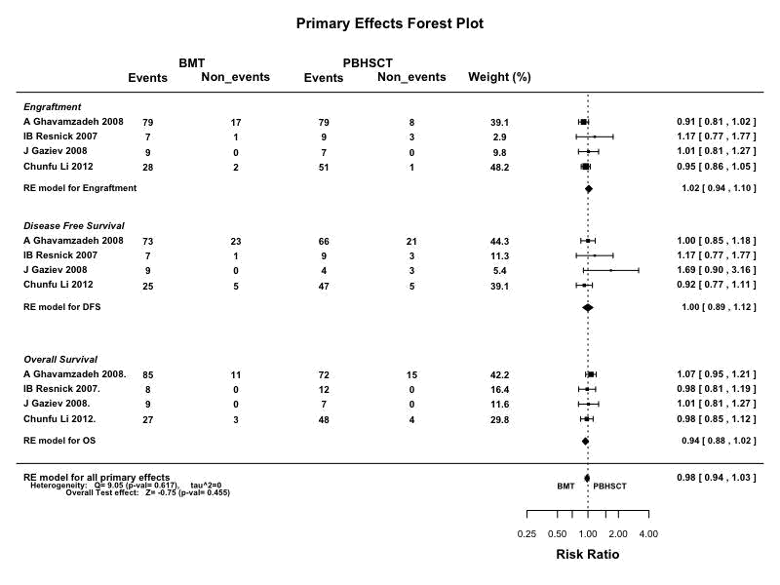

**Figure 1. PRIMARY OUTCOMES OF BMT vs PBHSCT**

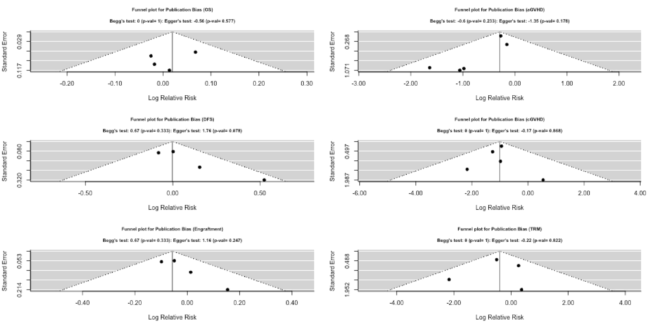

**Figure 2. SECONDARY OUTCOMES OF BMT vs PBHSCT**

**Figure 3. FUNNEL PLOTS DEPICTING PUBLICATION BIAS**

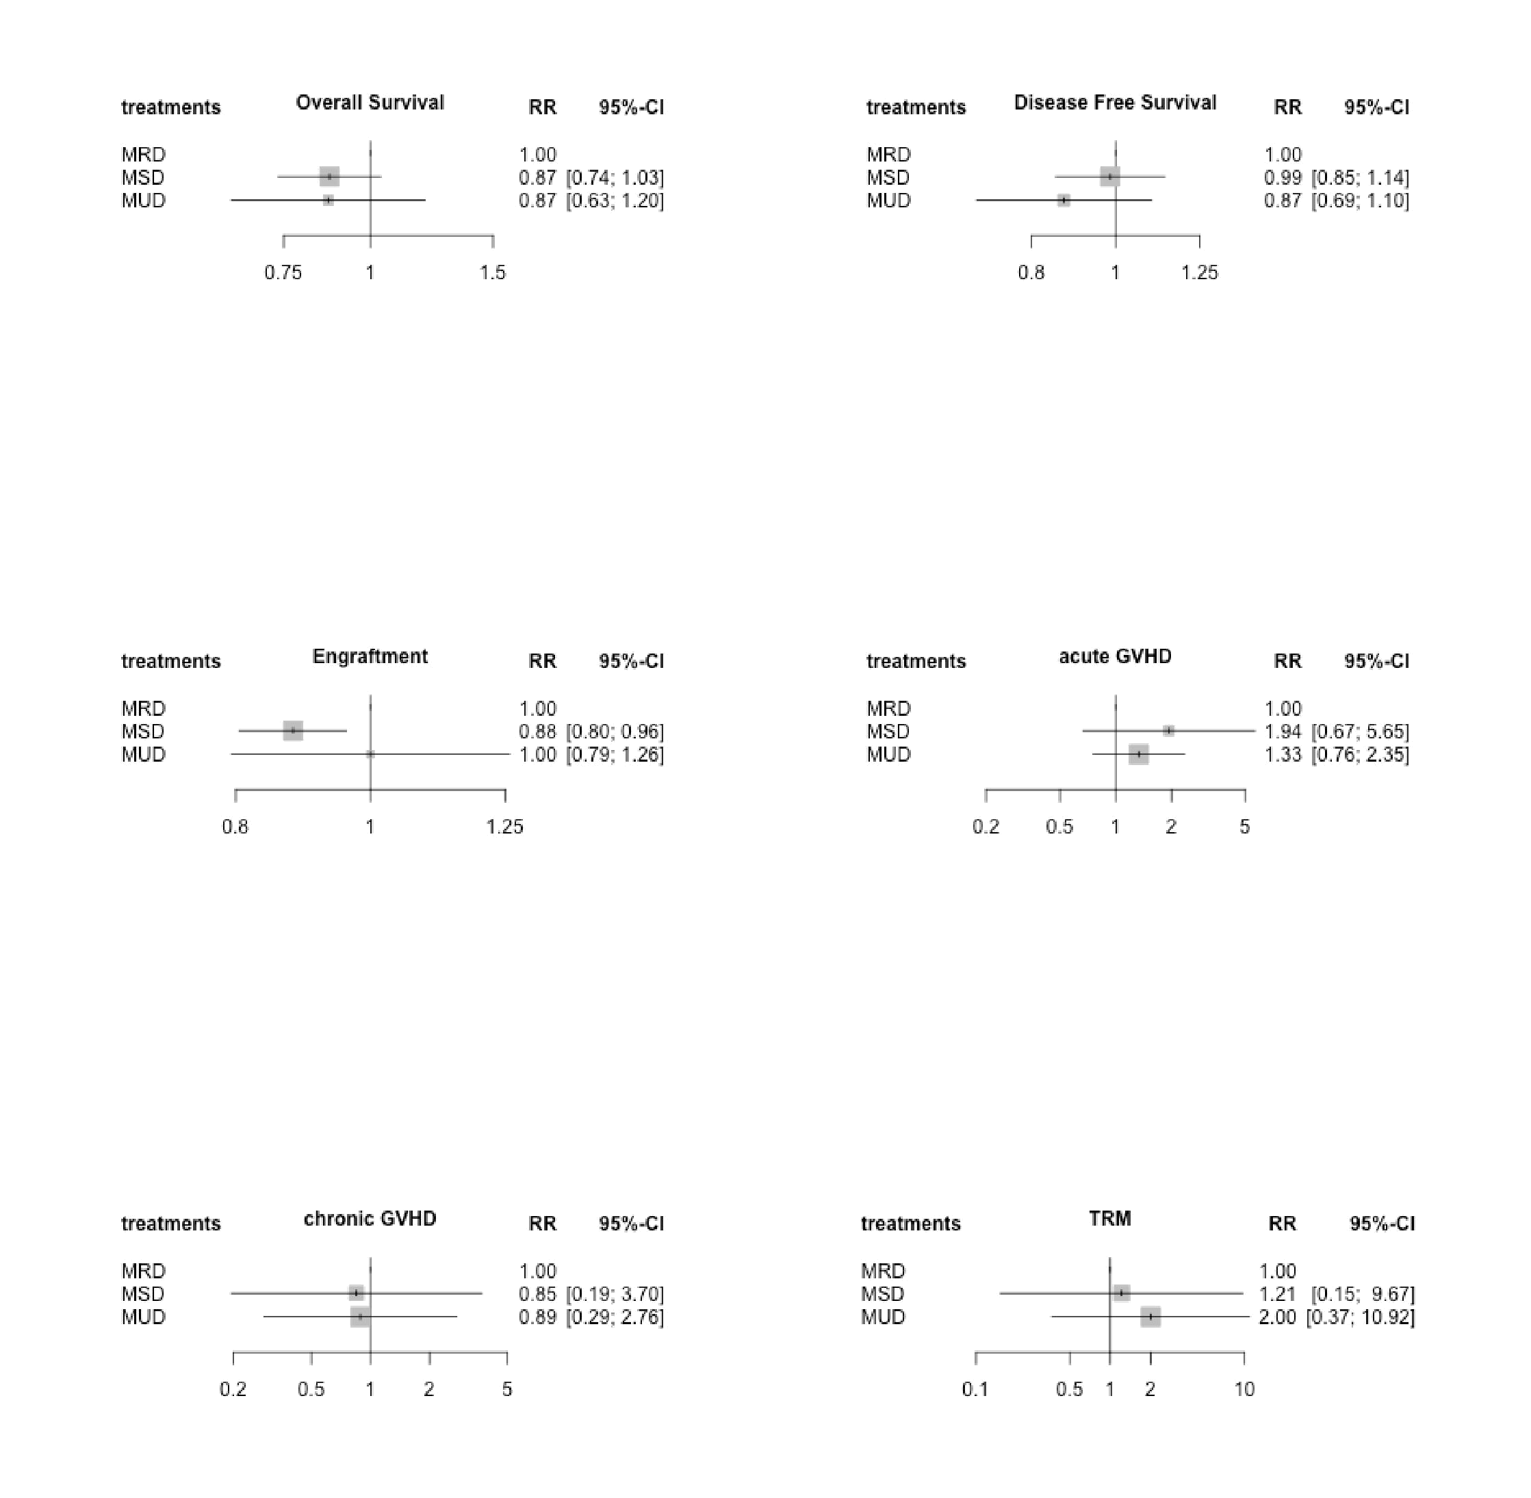

**FIGURE 4. PRIMARY AND SECONDARY OUTCOMES OF MRD-BMT VS MSD-BMT VS MUD-BMT**